H.T No
Regulations:
A18

Sreenidhi Institute of Science and Technology
(An Autonomous Institution)
Code No: 7AC41 Date: 20-Feb-2023 (FN)

B.Tech II-Year I- Semester External Examination, February/March-2023 (Supplementary)
BASIC ELECTRICAL ENGINEERING (CSE and it)

Time: 3 Hours Max.Marks:70

Note: a) No additional answer sheets will be provided.
b) All sub-parts of a question must be answered at one place only, otherwise it will not be valued.
c) Missing data can be assumed suitably.
Bloom's Cognitive Levels of Learning (BCLL)

Remember | L1 | Apply | L3 | Evaluate | L5
Understand | L2 | Analyze | L4 | Create | L6

Part - A Max.Marks:20

Answer all QUESTIONS.

 |  | BCLL | CO(s) | Marks
1 | Draw the V-I characteristics of Practical Voltage source and current sources. | L1 | CO1 | [2M]
2 | Define Form factor and peak factor, write the expressions for them. | L1 | CO2 | [2M]
3 | List various losses in DC machine. | L1 | CO3 | [2M]
4 | State the reason for conducting OC test on low voltage side of a transformer. | L1 | CO4 | [2M]
5 | List the advantages of three phase system. | L1 | CO5 | [2M]
6 | Define controlling and name the methods of employing it. | L1 | CO6 | [2M]
7 | Sate Faraday’s laws of electromagnetic induction. | L1 | CO1 | [2M]
8 | What is the function of Conservator tank in a transformer? | L2 | CO3 | [2M]
9 | State the reason for nonlinear scale in Moving Iron instruments. | L1 | CO5 | [2M]
10 | Why Three phase induction motor is self starting? | L2 | CO6 | [2M]

Part – B Max.Marks:50
ANSWER ANY FIVE QUESTIONS. EACH QUESTION CARRIES 10 MARKS.

 |  |  | BCLL | CO(s) | Marks
11. | a) | State and explain Kirchhoff’s laws with suitable examples. | L2 | CO1 | [5M]
 | b) | Find the equivalent resistance between the terminals A and B in the network shown below  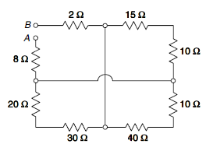 | L3 | CO1 | [5M]
12. | a) | Determine the RMS value and Average value of  the waveform shown below  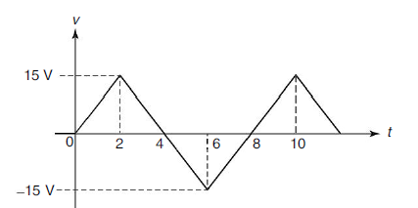 | L3 | CO2 | [5M]
 | b) | A series RLC circuit having a resistance of 8 Ω, an inductance of 80 mH and a capacitance of 100 μF is connected across a 150 V, 50 Hz supply. Calculate (i) current, (ii) power factor, and  (iii) voltage across the inductance and capacitance. | L3 | CO2 | [5M]
13. | a) | Explain the principle of operation of DC motor with help of relevant diagrams. | L2 | CO3 | [5M]
 | b) | A shunt generator supplies 95 A at a terminal voltage of 240 V. The armature and shunt field resistances are 0.2 Ω and 60 Ω respectively. The iron and frictional losses are 2000 W. Find the efficiency of DC generator. Also determine the value of load current at which maximum efficiency occurs. | L3 | CO3 | [5M]
14. | a) | Explain the construction of single phase transformer with the help of diagram. | L2 | CO4 | [5M]
 | b) | The OC and SC test data are given below for a single phase 5kVA,200V/500V,50Hz transformer  Calculate the voltage regulation and efficiency at full-load 0.8 p.f. lagging. | L3 | CO4 | [5M]
  OC Test from LV side | 200V | 125A | 150W
  SC test from HV side | 20V | 12.5 | 175W
15. | a) | Explain the principle of operation of three phase induction motor with the help of neat sketch. | L2 | CO5 | [5M]
 | b) | A 4-pole,3-ø induction motor operates from a supply whose frequency is 50Hz.Calculate  i) The speed at which the magnetic field of the stator is rotating.  ii) The speed of the rotor when the slip is 0.04. | L3 | CO5 | [5M]
16. | a) | Explain the essential features of indicating type measuring instruments. | L2 | CO6 | [5M]
 | b) | Explain the construction and working of attraction type moving iron instrument. | L2 | CO6 | [5M]
17. | a) | Calculate the current through the 10 Ω resistor in the network shown in Figure below using mesh analysis.  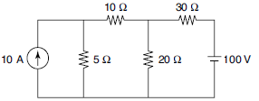 | L3 | CO1 | [4M]
 | b) | An RL series circuit is excited by a DC supply of 20V. Find the steady-state current, time constant, transient time and the induced voltage in the inductor after 10ms. Take the resistance and inductance value as R = 4Ω and L = 50mH respectively. | L3 | CO2 | [3M]
 | c) | Derive the EMF equation of a DC generator. | L2 | CO3 | [3M]
18. | a) | Explain principle of operation of single transformer. | L2 | CO4 | [4M]
 | b) | The input power to a 3-phase induction motor is measured as 5kW. If the voltage and current to the motor are 400V and 8.6A respectively, determine the power factor of the system and reactive power. | L3 | CO5 | [3M]
 | c) | A moving coil ammeter has a full scale deflection of 50 µ Amp and a coil resistance of 1000 Ω. What will be the value of the shunt resistance required for the instrument to be converted to read a full scale reading of 1 A. | L3 | CO6 | [3M]

-- 00 -- 00 –

